Spcm lab 10

**Lab Exercise 7– Creating Multiple IAM Users in Terraform**

**Objective:**

Learn how to use Terraform to create multiple IAM users with unique settings.

**Prerequisites:**

* Terraform installed on your machine.
* AWS CLI configured with the necessary credentials.

**Steps:**

1. **Create a Terraform Directory:**

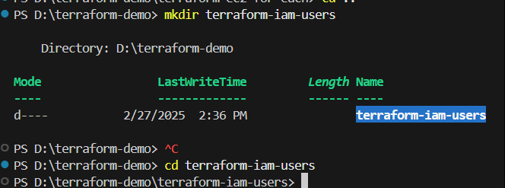

Iam.tf

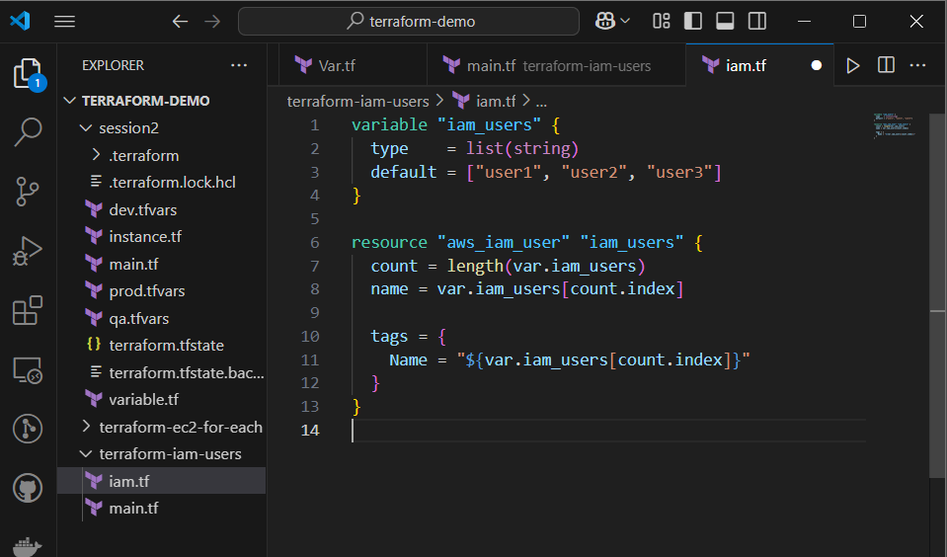

**Initialize and Apply**

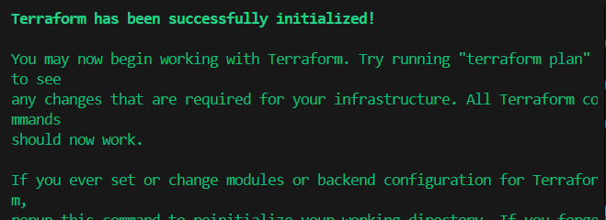

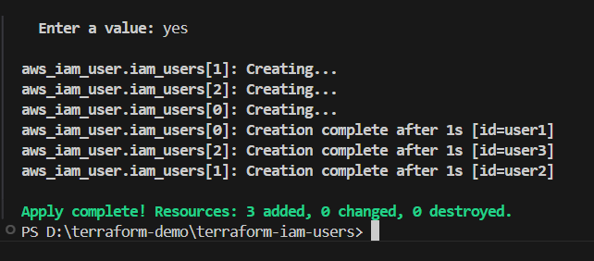

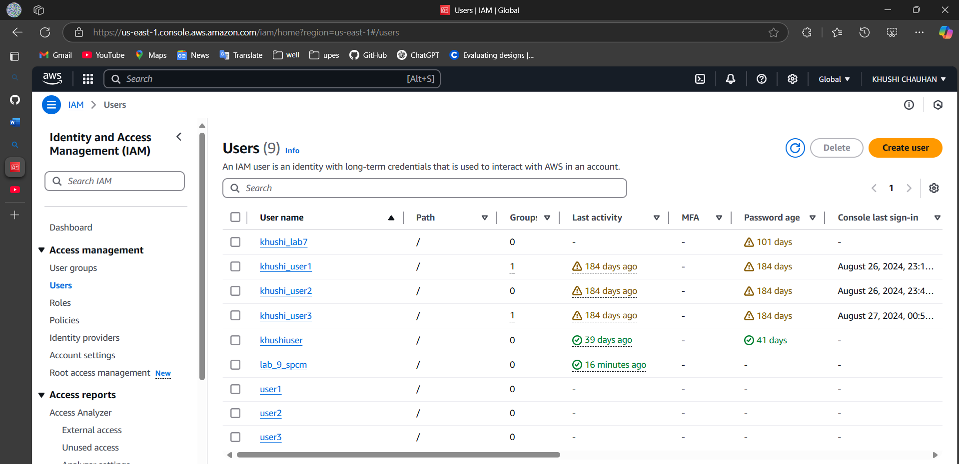

Destroy

